Data Mining and Warehousing (CSCS 455) Final Project Report

Recognize humor styles of people
Abstract
In our paper, we are going to recognize the humor style of people which will tell us about how people react towards different people and what kind of humor style is most common among people of different regions. A cluster analysis of participants based on their self-ratings regarding Aggressive, Self-defeating, Affiliative, and Self-enhancing humor styles was performed. Four clusters of people were identified consisting of those who score: (1) above average on all the styles, or (2) below average on all the styles, or (3) above average on the positive styles (Affiliative and Self-enhancing), and below average on the negative styles (Aggressive and Self-defeating), or (4) above average on the negative styles and below average on the positive styles. Big Five personality and Self-esteem correlates of each cluster are reported and the theoretical, practical, and research implications of the findings are discussed.
In this paper we use three different models for determining the accuracy of the program: KNN model, Decision Tree model and Multiple linear Regression. We compare which model has highest accuracy and how much variance there is in humor styles. From our results we can see that MLR has highest accuracy of 98%. Decision tree model and KNN Algorithm gave low accuracy which was around 70-74%

Introduction
A little humor is good for the soul”
Richard Branson
“A sense of humor is part of the art of leadership, of getting along with people, of getting things done.” Dwight Eisenhower
Humor studies are well established in disciplines such as linguistics and social science (Robert and Yan, 2007; Wijewardena et al., 2017). Since Malone (1980) postulated the cases for and against humor in the workplace, a growing body of literature started to emerge in business management, leadership and organizational psychology (Decker and Rotondo, 1999; Scheel and Gockel, 2017). These studies indicate the positive influence humor has on a range of desirable organizational outcomes, such as group cohesiveness (Holmes and Marra, 2006), team performance (Mao et al., 2017), employee resilience and coping (Vetter and Gockel, 2016), citizenship behaviors (Tremblay and Gibson, 2016; Tremblay, 2017), and leadership effectiveness (Mesmer-Magnus et al., 2012). Humor in leadership has attracted an increased amount of empirical research in recent years (Cooper et al., 2018; Kong et al., 2019), as leadership is a key element of organizational effectiveness and business success. Given its social and commercial value, leader traits, leadership competencies and leadership styles have been extensively studied to enhance understanding of the core makeup of a good leader and what constitutes effective leadership (Avolio, 2011). Anecdotally, humor has long been recognized as a desirable trait for leaders and an effective leadership tool that is underutilized (Malone, 1980; Duncan, 1982; Vecchio et al., 2009). However, the challenge of studying humor in leadership begins with the definition of humor being fluid and as a result, it is difficult to assess the construct directly.
(“https://www.frontiersin.org/articles/10.3389/fpsyg.2021.610795/full”)
In our project, we have tried accurately predicting humor style by looking at the style of the person with the help of response given on the questionnaire. We have used 3 different algorithms for this purpose and gained an accuracy of 74-98%. MLR proved to be the best classifier among them which showed Accuracy around 98%. We have also attempted to show and visualize the result of our study.
Machine learning algorithms that are used in this project are K-nearest neighbor Classification, Decision Tree, and Multi Linear Regression. The K-nearest neighbor used is the type of supervised machine learning. It will simply calculate the distance of the new data point to all other training data points. The distance can be Euclidean or Manhattan type. Then it will select k nearest data points, where K can be any integer. Finally, it will assign data points to the class that has most k data points. In this case, the style that we will select will be data points and it will try to find which class these styles belong to and that’s how this algorithm will predict styles of humor. Results of this model is not impressive, as it gave accuracy around 70% which is quite low.
Decision Tree algorithm also belongs to the supervised learning algorithm. It is used for regression and classification. However, in this project, we will use classification as we know the humor and will just tell style to know which class these styles belong to. In decision tree, for prediction, uses the method of tree diagram at the top. This tree has a root node after which it gets split into a feature which is dominant, and it keeps splitting repeatedly until all inputs are placed and at the node, the extreme last node will contain all the weights and, on these bases, weights will classify the input given. In our case, we will give styles corresponding's (x values) and it will classify the given input and tell us the humor style (y values). It showed accuracy around 70 % which is quite low.
Multiple linear regression (MLR), also known simply as multiple regression, is a statistical technique that uses several explanatory variables to predict the outcome of a response variable. The goal of multiple linear regression is to model the linear relationship between the explanatory (independent) variables and response (dependent) variables. Multiple regression is the extension of ordinary least-squares (OLS) regression because it involves more than one explanatory variable. In our case, we will provide x variables and y variables (styles of humor) from our dataset to train our dataset and it also tests accuracy show results by applying regression. It showed accuracy around 98 % which is quite good.

Literature Review
Several attempts have been made to explore and model humor using computers, most of which can be found within the growing field of Computational Humor. These approaches are truly diverse in that they build on different theoretical foundations, look at different subtypes of humor, take different approaches to modeling, vary in their degree of detail, and are used to solve isolated tasks. The goal of this project is to model and detect instances of sequential humor involving the formation of incongruity and resolution over time in a sequential fashion which this literature review will focus on. We will first describe Incongruity-Resolution based theories of humor, second, we will look at different theories of humor which specifically focus on sequential humor such as forced reinterpretation, frame shifting, and garden path humor, third we will look at several computational techniques used to represent and work with meaning using computers, and finally we will discuss some recent approaches to modeling sequential humor using computers which led to viable results. What we have found is not that the models used experimental and diverse, but no approach has made use of text visualization.
Humor studies are increasingly prevalent in workplace and leadership domains, it has shown significant development in the last 40 years. The multifaceted nature of humor means varied definitions and diverse measurement approaches have been approved. As a result, research methodologies and findings are not easily clarified, and have not been synthesized. The aim of this scoping review was to review the existing body of literature relevant to humor in workplace leadership to identify key research areas, methodologies used, guiding theoretical frameworks, and gaps that have persisted over the last 40 years. Using qualitative review methods, four key themes in the research emerged relating to: (1) humor styles and outcomes; (2) humor as communication and discursive resource; (3) variables in the humor and leadership relationship; and (4) cultural context. This review demonstrates significant research progress on the topic of humor in workplace leadership. Research progress and gaps are discussed based on five key questions. Future research directions are outlined and discussed.
In recent years, humor motivation has become a focus of substantial research interest, with particular emphasis on its role in social interaction1,2. Humor is a fundamental feature of social life and can be used with distinct motivations and targets. Humor is often used in a positive interpersonal manner and in contexts perceived to be playful, safe, nonserious, or, in other words, benign3. However, some humor expresses the motivation to disparage its target4, exert superiority over others5, or release repressed aggressive tension6.
The humor styles questionnaire (HSQ) developed by Martin et al.7 is a self-report measure of personality traits. It can be used to identify individual “sense of humor” differences in the use of four distinct styles of humor. These four styles are based on positions along two underlying dimensions. The first dimension is related to the intent motivating humor and emphasizes differences in benign and detrimental humor. The second dimension is related to the target of humor, with some humor being directed towards the self and some humor directed towards others. Based on these two dimensions, then, one’s sense of humor can be categorized in terms of four humor styles: self-enhancing humor (SE, benign humor that directly enhances the self), affiliative humor (AF, benign humor that facilitates relationships with others), self-defeating humor (SD, detrimental humor that facilitates relationships with others at one’s own expense), and aggressive humor (AG, detrimental humor that indirectly enhances the self at the expense of others)

Methodology:
There is one dataset file data.csv which contains outcome values which tells about style of humor which is depending on response of questions which are x variables,
Dataset:
It is the only dataset which is being used in this project 20% for training and 80% for testing. It consists
of columns which tell us about humor based on style which is a response recorded from the questionnaire, and these are preprocessed so it makes it easy to classify the data. This data set will be used to train our model.
Number of columns(attributes) are 39 and 5 humor styles are there and number of rows(instances) are 1072.

Evaluation of results
Decision Tree Model
Fig 1

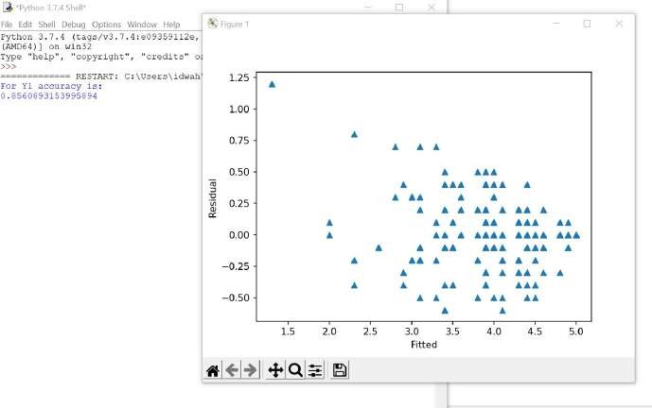
Fig 2
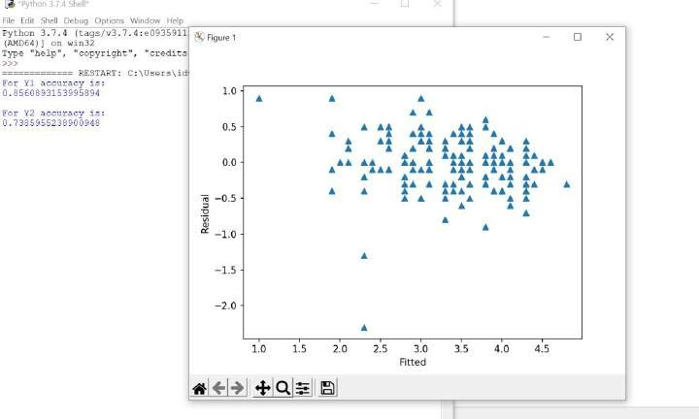

Fig 3

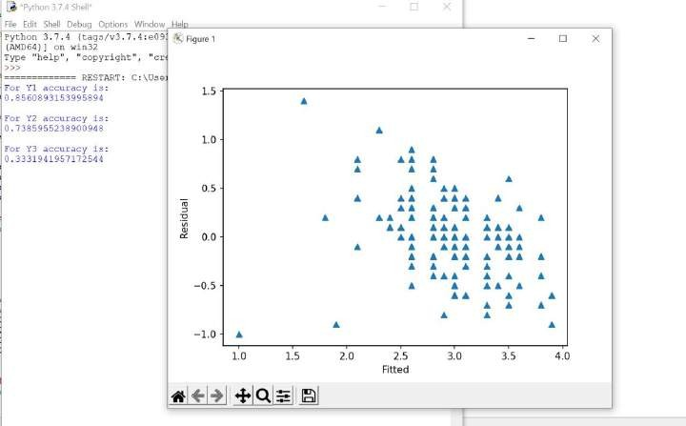
Fig 4

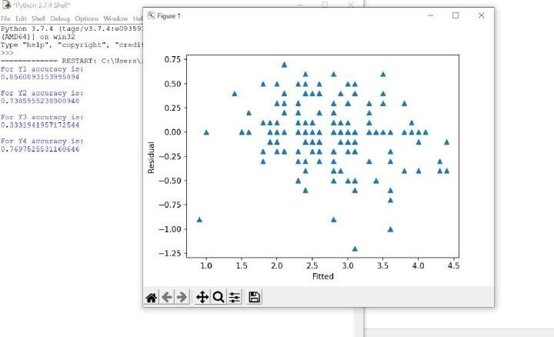

Fig 5
Accuracy

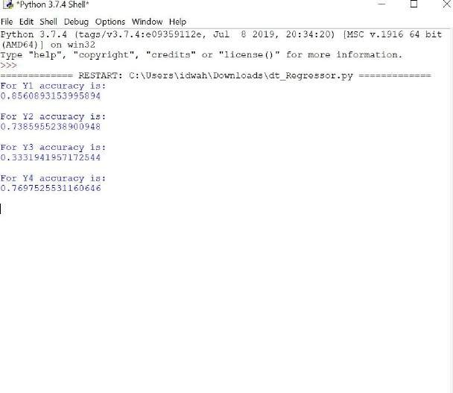

Result:
In this algorithm, the Evaluation technique we used was an Accuracy test. As you can see, the accuracy we gained by applying decision Tree algorithm was quite low. It gives us around 70 % accuracy. Graph shows scattered data points which is the reason it not a good classifier for this example.

Multiple Linear Regression
Fig 1

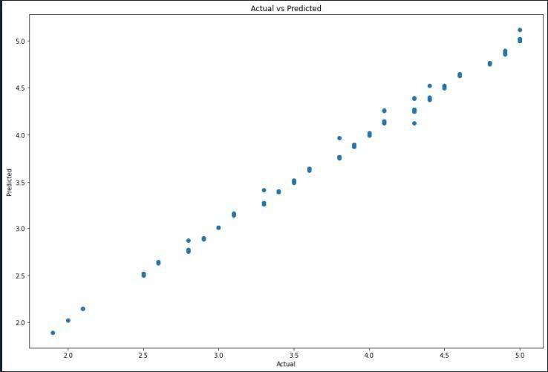

Accuracy:

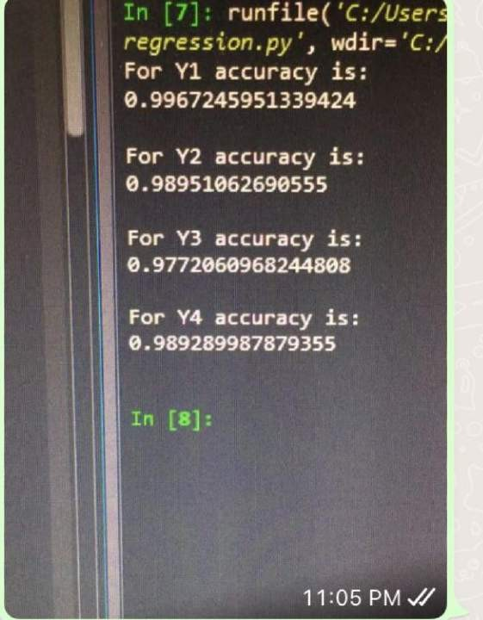
Result

In this algorithm, the Evaluation technique we used was an Accuracy test. As you can see, the accuracy we gained by applying the MLR algorithm was very satisfying. It gives us around 98 % accuracy. Graph shows straight line data points which is the reason it a good classifier for this example.

KNN Algorithm
Fig 1:

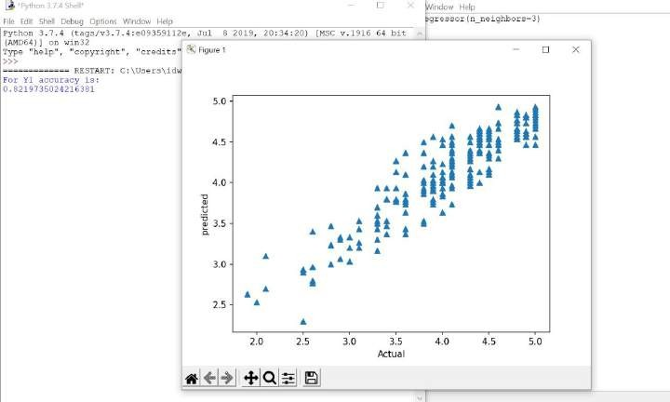
Fig 2:
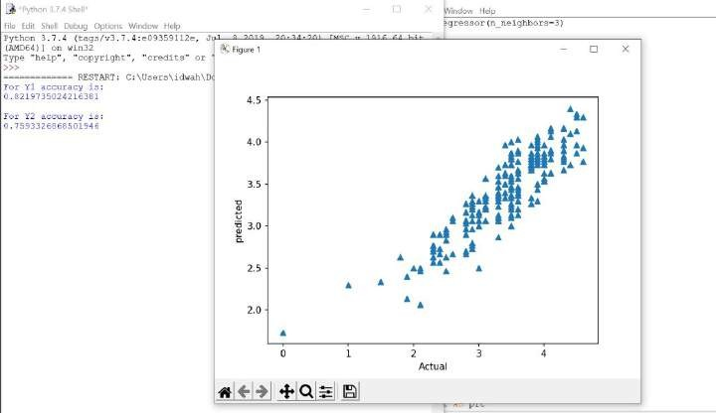

Fig 3:

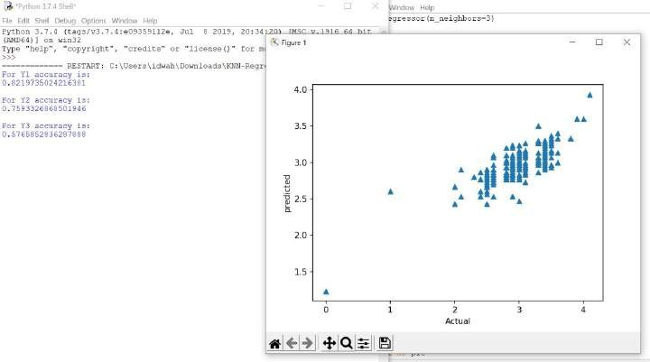
Fig 4:

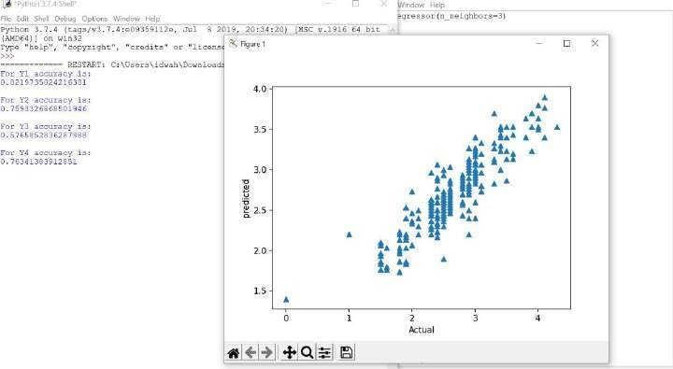

Accuracy:
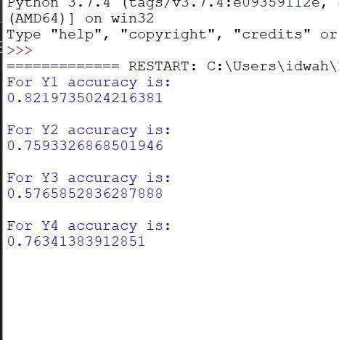

Result:
In this algorithm, the Evaluation technique we used was an Accuracy test. As you can see, the accuracy we gained by applying the KNN algorithm was not very satisfying. It gives us around 70% accuracy. Graph shows scattered dotted line. It is not a good classifier for this example.

Comparison between graphs

MLRDecision Tree
KNN

Comparison
MLR proved to be the best classifier, as you can see in the graph that line is straight and in other graphs there are scattered datapoints. It is concluded from these diagrams that MLR is the most suitable classifier for this dataset acquired

Conclusion
In this paper we tried to make a system which can predict human humor style, by using different classifiers. MLR proved to be the best classifier, as it showed the highest accuracy, among others. It is concluded that Decision Tree and KNN algorithm was not a suitable classifier for this example. This system can help to predict humor style of people from different countries and nations.

References
https://digitalcommons.cwu.edu/cgi/viewcontent.cgi?article=1089&context=graduate_projects https://www.sciencedirect.com/science/article/abs/pii/S0191886909005133 https://files.eric.ed.gov/fulltext/EJ1287919.pdf https://www.frontiersin.org/articles/10.3389/fpsyg.2021.610795/full https://www.ncbi.nlm.nih.gov/pmc/articles/PMC6199304/

